Time management

Why is time management important?
Time management is the process of planning and allocating your time in accordance to the tasks that you have to complete.
Studying at a HE Level means you have to manage your time accordingly. This could mean you have to balance your studies with employment and leisure.
Without thinking about your time management you could find this difficult to do. However there are a number of different techniques that you can use to aid you which can help you prioritise tasks, projects or goals.

Key tips
Don’t procrastinate
Procrastinating is putting off work or having the attitude of “I’ll do that later”. Procrastinating will inevitably mean that you have less time to complete your work.

Don’t try and do it all at once
Your brain doesn’t work as well if you’re looking at the same thing, or trying to do the same task for hours on end.

Break your work into manageable chunks
If it is an essay or report for example, there will be clear sections that you can break your assignment up into. By doing this is means you will achieve smaller but vital goals.

Give yourself rewards
Achieving your goals is a good thing! Reward yourself with a break, or lunch with friends. This will help you balance your life with work.

Have regular breaks
Breaks can help you re-gather your thoughts and re-energise. During your breaks you should try and drink plenty of water.

Plan, but plan well
Don’t make a plan for plans sake (this is procrastinating!). Make sure you create a plan with clear goals and outcomes

Plan for unforeseen circumstances
Ensure you overestimate how long it will take you to complete a piece of work as in life things crop up unexpectedly, so you need this extra time to take care of these.

Different methods of time management
Below you will find a selection of time management theories, you may find one or a number of them useful.

The Pickle Jar Theory
Imagine an empty jar. A big jar. A jar that can fit 5 giant pickled onions in.
The thing to do next is fill the jar full of large rocks, as many as you can. Do you think you can fit anything else in? Try putting in a few small pebbles into the smaller spaces. It’s full now right? Well how about pouring sand into the jar? Well it’s definitely full now right? Try pouring water into the jar.
Now I think we can agree the jar is finally full.
The purpose of the exercise is that the jar symbolises your time and capacity. The rocks are the big priorities in life, the pebbles some smaller and less integral tasks or hobbies. We also have other things to do that we have to squeeze in our life, this is represented by the sand. Then there is the water. This is everything else we have to consider which gets in the way of the bigger things.
The important thing to remember about the pickle jar theory is that none of these elements are bad. We need the large priorities trickling down to the lower importance objects for our lives to feel fulfilled.
The key thing about the pickle jar is that you make time for everything. If you allocate your time correctly to your priorities, everything will fit in the jar!

The Eisenhower method
Covey (1989) spoke of the potential usefulness of the Eisenhower Method. The method helps you decide which tasks you should or shouldn’t prioritise. The method helps you divide actions into one of four categories. The quadrants are divided by importance and urgency.
The quadrant is easy to use. You simply choose a task of you to do list and ask yourself the 2 questions ‘is it urgent?’ and ‘is it important. Once you have plotted your tasks onto the grid, you should then be able to form a list of tasks in priority order.

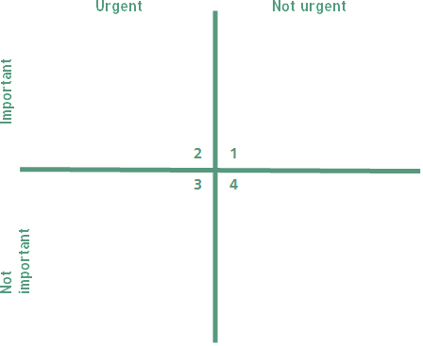

To sum up…
Regardless of which method you choose, it is important to remember that you need to review your priorities as new things will come up, and take the priority over the existing.

References
Persky, Joseph. 1992. Retrospectives: Pareto's Law. Journal of Economic Perspectives, 6(2): 181-192.

Covey, S. R. 1989. The 7 habits of highly effective people: Restoring the character ethic. New York: Simon & Schuster.
Juran J.m,. 1988. Quality Control Handbook, 4th edition., McGraw-Hill.

