A guide to report writing

What is a report?
A report is a highly structured form of writing, more structured than an essay or piece of reflective. It is designed so it can be read quickly, easily and accurately.
Reports have clear structures which make them easy to read, below is a typical report structure:
- Title page
- Acknowledgements
- Contents
- Summary
- Introduction
- Methodology
- Results/findings
- Discussion
- Conclusion/recommendations
- References
- Appendices
Reports are written on a wide variety of subjects for many different reasons; before writing your report it must be clear the objectives for your report whether it is to communicate findings, inform decision makers, change public opinion or maintain development. Whatever the purpose of the report you must always think about who the intended audience for the report is and think about the ideas/results/findings they will be interested in.

Stages in report writing
The following stages should help you write your report:
- Planning
- Collecting information
- Organising and structuring your information
- Writing the first draft
- Checking and redrafting
It is good practice to draw up your own outline structure for your report and set yourself a sensible timescale in which to complete your writing.

The four P’s
One common structure is based on the 4 P’s (Hemmingway, 1993).
- Position
- Problem
- Possibilities
- Proposal

First you should position your work in the subject area, where does your work fit in with other work in the area? Then you should outline or clarify the problem, what are you researching and why does it require investigation? The next section requires you to examine the possibilities of the situation- what could be done differently? Why? Who? Lastly the work should decide upon a proposal or suggest a way in which this work could be developed and the problem addressed?

Layout and presentation
Most reports use a progressive numbering system, the most common system is the decimal notation system.
- The main sections are given single numbers eg; 1,2,3
- The subsections are given decimal numbers eg; 1.1, 1.2, 1.3
- Subsections can be further divided eg; 1.1.1, 1.1.2, 1.1.3
Your report should be word processed, as it needs to be clear and easy to read. It may also require the following format, but you should clarify these with your tutor if you are unsure.
- Leave wide margins for feedback/comments from your tutor
- Avoid rambling by using short sentences
- Paragraphs should be short and concise
- Avoid using unnecessary jargon and unexplained abbreviations
- List your standard measurements, units and technical terminology in a glossary at the end
- Headings should be clear- highlighted in bold or underlined
- Quotes should be in italics
- Label graphs or drawings as ‘figures’, eg; figure 1, figure 2
- Label tables separately as ‘table’ eg; table 1, table 2

What does an effective process for writing look like?
The following sequence is an effective process to draft and revise various sections of writing
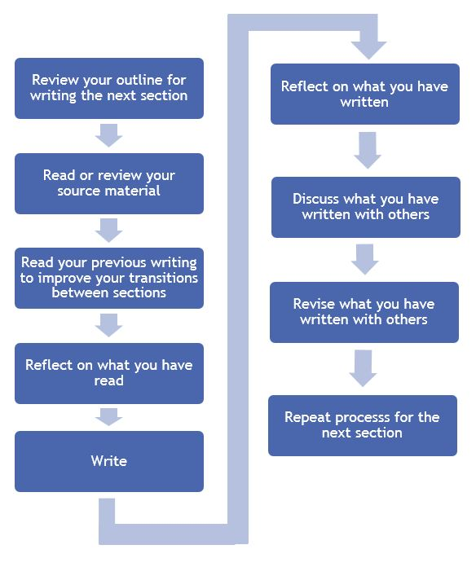

References
Developed from original works by:
Sampson, James P. Jr., 2012. A Guide to Quantitative and Qualitative Dissertation Research. [Online] Available at: http://diginole.lib.fsu.edu/edpsy_faculty_publications/1/. [Accessed 14/02/2014]

