A guide to understanding Turnitin

What is Turnitin?
Turnitin is a way for students to electronically submit their work, at Loughborough College you can access your Turnitin submission link through LearnZone. Turnitin allows tutors to read, assess and give feedback on students’ work electronically. Turnitin has a feature called “Originality checker” which allows tutors to easily see where aspects of a submission appear elsewhere. Turnitin checks a student’s submissions against online websites, journals, articles and books. When your work is similar, or the same as, another source it is flagged up as a percentage of the submission.

Why is Turnitin used?
A tutor may use Turnitin as a way to allow students to submit their submissions electronically. The tutor will set up a Turnitin submission through the relevant page on LearnZone, by accessing Turnitin through LearnZone it is easy for students and staff to find the right Turnitin submission and easily submit to it, using an interface that is familiar.
A tutor may also choose to use the “Originality checker” feature of Turnitin, this will help them to identify if a submission has been correctly and completely referenced and will also help to highlight if the work, or aspects of the work, have been plagiarised. The tutor will be able to see the where a source is within a submission, the source will be highlighted and will have the percentage of the word count that it accounts for. The tutor may decide to share the originality report with each student, or they may only use it to inform their feedback on the submission.
There is no right or wrong percentage of referenced material that each submission should contain, the tutor will use the percentage figure to help them to make a decision about how accurate the references are and whether there is any accidental plagiarism within the submission.

How can Turnitin help me?
When a submission is uploaded to Turnitin the student will automatically receive a receipt for the submission to their student email (college email account). This will act as proof of submission should it be needed and allow the student to be confident that their submission has successfully been uploaded to Turnitin.
When a tutor marks a submission through Turnitin the student will receive clear and easy to read feedback. The tutor has the option to make comments straight onto a submission, make overall comments in the box on the right hand side or record an audio file to give feedback on the submission. The tutor will be able to see which students have read the feedback placed on their work, it is advisable that all feedback is read as soon as it becomes available.
Knowing how an originality report is displayed can help students to learn how to write effectively, without paraphrasing or plagiarising work. By knowing that any part of a submission will be flagged if it is similar to any the sources that Turnitin checks, It is possible to learn how to properly reference all parts of a submission and also how to interpret key points in your own words whilst still acknowledging existing work.

Turnitin feedback
Below is an example of feedback given through Turnitin. The numbers in the boxes relate to the numbered explanations below the image.

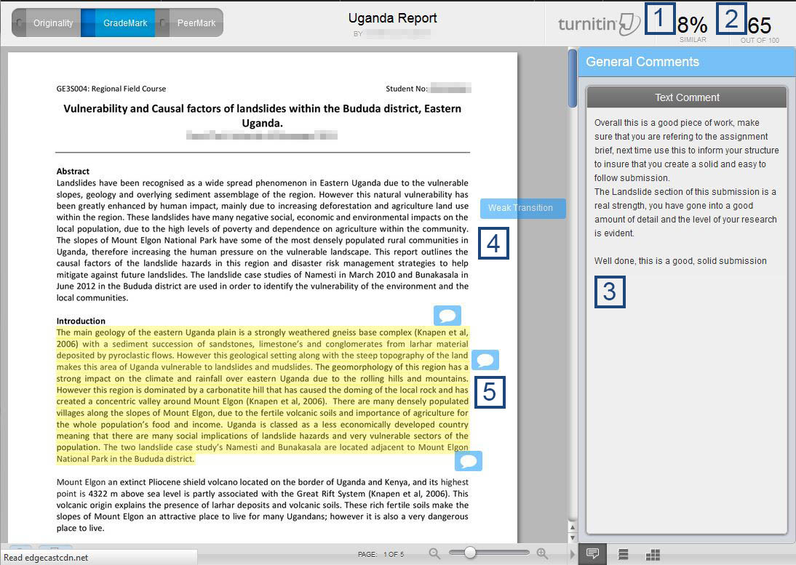

1. This is the percentage of your submission that is similar to other sources, there is no right or wrong percentage of similarity.
2. This is the grade that the tutor has awarded the paper, this is not compulsory for a tutor to complete so if there is a “- -” where a mark should be, the tutor has chosen to leave this blank.
3. The text comment box is where a tutor can leave overall feedback about the submission, this section is normally used to explain strengths and weaknesses of the submission.
4. This is a grammar comment, a tutor can place these straight onto the submission to quickly highlight any issues. When the blue box is clicked (within Turnitin) then more information will be displayed, elaborating the short statement.
5. A tutor may choose to add comments straight onto a submission, they can choose to add speech bubbles straight onto the submission or highlight a section of text and then comment on the highlighted text using a speech bubble – click on the speech bubble to expand it and see the comment that has been written.

The originality report
Below is an example of an originality report. A tutor has the option to share this with the student that has submitted the work, or keep it hidden from them. The numbered explanations below help to explain the layout of the originality report.

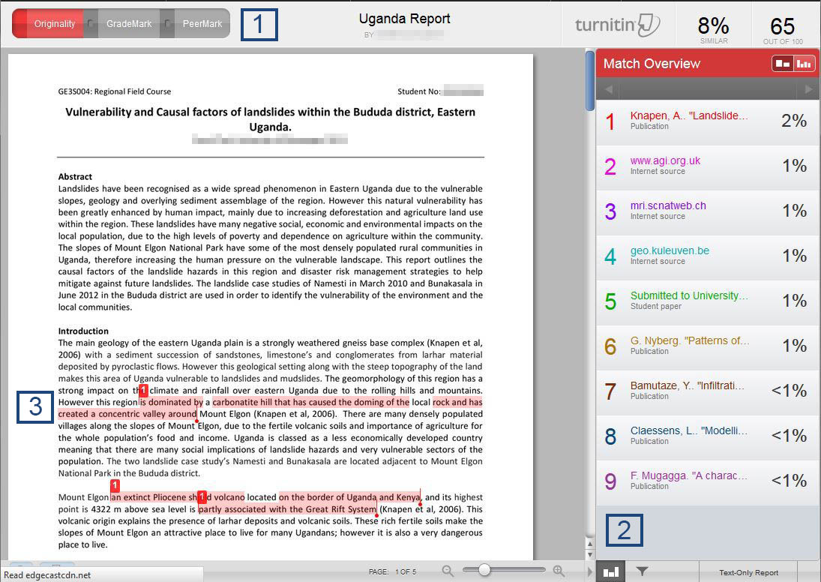

1. These tabs allow you to swap between the different views that are available. The two tabs on the left are available at Loughborough College (at the time of writing PeerMark is not available). It is possible to tell which view is being displayed as the corresponding tab will be lit up.
2. The column on the right hand side of the screen displays all of the matches that Turnitin has found to be similar to the submission. Next to each of the entries in the column, the percentage of the match will be displayed, it will also be highlighted in the text in the corresponding colour.
3. An example of a match highlighted within the text of the submission. Each highlighted match will have a number next to them, this corresponds to the number in the column on the right hand side of the screen.

Where can I find more information about Turnitin?
This student user manual, produced by Turnitin, is a good source of information if more information is needed about how to use Turnitin.
http://pages.turnitin.com/rs/iparadigms/images/en_us_moodle_native_integration_student_manual.pdf

