A guide to copyright

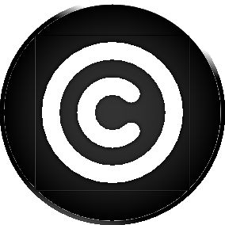
What is copyright?
Copyright is the way that people’s work is protected. It is automatically created and applies to many different types of work, including music (the recording and the score), film, theatre and books as well as other types of works.
“Copyright protects written, theatrical, musical and artistic works as well as film, book layouts, sound recordings, and broadcasts.” Intellectual Property Office.
Some facts about copyright, did you know?
- Copyright is the exclusive right to make copies, license or otherwise exploit an artistic ‘work’
- There is no official registration system for copyright, it is automatically created and is an automatic right
- Copyright is an exclusive legal right given to the creator of the work

Why is copyright important to me?
Copyright infringement is a serious offence, it could lead to disciplinary action taken against you by the college or legal action taken against you by the copyright holder. Whenever you use anyone else’s work you must always reference it, by doing this you are acknowledging that the work is not your own.

What type of work is covered by copyright?
It is safe to assume that most work is covered by copyright, as copyright applies to any medium, however below is a list of types of work that are covered by copyright.
- Literary – Song lyrics, manuscripts, manuals, computer programs, commercial documents, leaflets, newsletters and Articles, etc.
- Dramatic – Plays, Dance, etc.
- Musical – Recording and score
- Artistic – Photography, painting, sculptures, architecture, technical drawings/diagrams, maps, etc.
- Typographical arrangement of published editions - Magazines, periodicals, etc.
- Sound recording - May be recording of other copyright works, e.g. musical and literary
- Films
- Broadcasts and cable programs

How long does copyright last?
Copyright expires after a certain length of time, the time is dependent on the type of work.
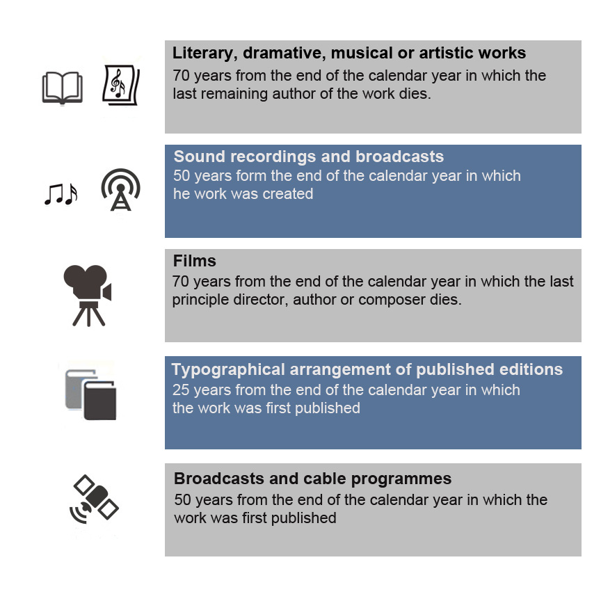

Copyright rights
Copyright gives the creators of certain kinds of material rights to control ways which all their material can be used. A copyright holder has the right to wave some, or all of these rights. This is why it is important to know about Creative Commons and public domain licences as well as copyright licences.
The © symbol is used to represent copyright, all rights reserved – meaning that you cannot use, change or adapt the associated work for any reasons.
The creator of the work has the right to – copy, adapt, distribute, send/communicate it to the public by electronic transmission, rent or lend copies to the public and perform the work in public.

How to make sure that you use other people’s work properly
Make sure that you are familiar with the style of referencing that you have been asked to use. If you are not sure what style of referencing you are supposed to be following, ask your tutor. There are two referencing styles in use in Loughborough College, they are Harvard Referencing and APA referencing. There is a guide available for each of these referencing styles in the Study Skills section of the College website.

Copyright at Loughborough College

The Copyright Licensing agency
Under the Copyright, Designs and Patents Act 1988 you are allowed to photocopy materials for personal use, this normally allows you to photocopy an A4 size copy for personal study use. The Copyright Licensing Agency (CLA) looks after the rights of authors of material and monitors the copying from books, journals and periodicals. It also re-distributes the money form license payments to authors and artists.
Loughborough College holds a special licence agreement with the CLA, which allows staff and students to make multiple copies of work for educational use. Copying means that you are allowed to photocopy the material not creating an electronic copy (such as scanning or taking a photo).

What can I copy under the CLA licence?
Under the College CLA licence you can copy:
- Up to 5% of 1 book or a complete chapter
- 1 whole short story or 1 poem (not exceeding 10 page)
- 1 article from a journal
- Enough copies required for personal use by the whole class.

What can’t I copy under the CLA licence?
You cannot copy:
- Printed Music (including the words)
- Newspapers
- Maps, charts or books of tables
- Publications which specifically say they are not to be copied under the CLA licence
- Published examination papers and published tests
- Workbooks and worksheets
- Privately prepared teaching material
If you use anything that you have copied under the CLA to inform your assignments, you must still fully reference it.

Other licences held by the College

The Educational Recording Agency (ERA) licence
This licence allows the College to record television programmes from all terrestrial channel (except the Open University). These videos can be used in College or at home and can be edited as long as they state the source of the material – i.e. BBC, date and programme.

Performing Rights Society (PRS) Licence and Phonographic Performance (PPL) Licence
This licence allows the College to play pre-recorded music on CD, tape on radio broadcasts in a public place. – i.e. In the restaurant, sports gym or hairdressing salons.

Newspaper Licensing Agency
This license allows the College to photocopy articles from a newspaper on to paper (this does not cover electronic copying through scanning or photography).

Ordnance Survey Licence
This license allows students to make printed copies of ordnance survey maps for educational, research or teaching purposes. This licence does not cover electronic or digital copies, as this requires a further licence.

What is Creative Commons?
Creative Commons is a non-profit organisation that helps people to share their works and allow other people to use copyrighted works, with certain restrictions. There are different types of Creative Commons licences that the creator of a work can decide to license their work under.
The 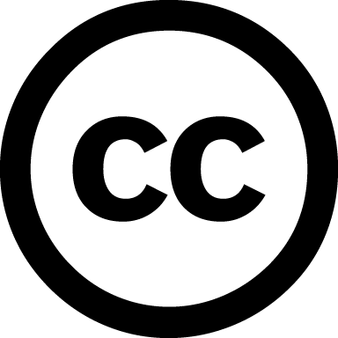 symbol is the symbol used to represent Creative Commons.
People who choose to use Creative Commons licences are contributing to the Commons, a global pool of reusable works, and are helping to create a culture of sharing, reuse and innovation.

Creative Commons licences
There are 6 types of Creative Commons licence, each Creative Commons licence outlines what exactly you can do with/to the copyrighted material. The image below briefly explains what you can do with each type of Creative Commons licence.
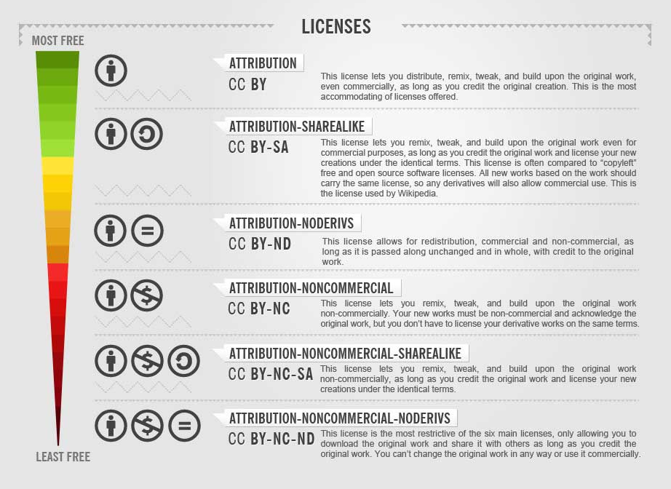

Using images in your work
In your work you must only use images that you have permission to use. This usually means using images that are Creative Commons or photos that you have taken yourself. When you use a Creative Commons image you must always attribute the creator of the work, when attributing work you should hyperlink the creator’s name and link it to the original work. If your work is going to be printed out you should put the name of the creator next to the image in your work and then reference the hyperlink below the reference list.

Finding Creative Commons images
Google have recently introduced a way to search for Creative Commons images easily through their Google image search. To search for Creative Commons images follow the steps below.
- Go to Google image search and type in your search term(s)
- Click on “search tools”
- Click on “usage rights” and then choose from the drop-list. Please note, it is important that if you are going to edit an image (in any way) you must choose the option that includes “modification”.
- Choose your image from the images on the page.

Using videos in your work
Using video is a good way to add variety and help explain points in your assignments. However, like with using images we have to be careful about what videos we use and whether we have the right to use the video. Videos are subject to the same Copyright Law as images. One of the best and easiest ways of finding videos to use in your work is by using YouTube. You can embed a video into your work without downloading it, so the person viewing your work can always visit the original video on YouTube.

References
About the Licenses. Creative Commons. [online] Available at: <http://creativecommons.org/licenses/> [Accessed on 19 December 2013]
Fact sheet P-01: UK Copyright Law. The UK Copyright Service. [online] Available at: <http://www.copyrightservice.co.uk/copyright/p01_uk_copyright_law> [Accessed on 19 December 2013]
Intellectual Property Office. 2012. [online] Available at: < http://www.ipo.gov.uk/copy.htm > [Accessed on 19 December 2013]
Creative commons licences image <http://rack.2.mshcdn.com/media/ZgkyMDEyLzEyLzA4L2RkL0NDaW5mb2dyYXBoLmpJei5qcGc/f9f19a65/65e/CC-infographic.jpg >

